HttpSessionEvent and HttpSessionListener-

|  |
| --- |
| the HttpSessionEvent is notified when session object is changed. The corresponding Listener interface for this event is HttpSessionListener. |

|  |
| --- |
| We can perform some operations at this event such as counting total and current logged-in users, maintaing a log of user details such as login time, logout time etc. |

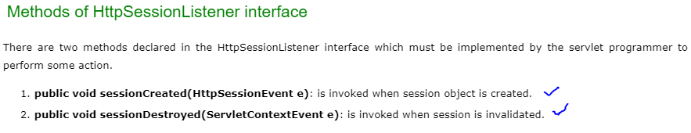

### **Example of HttpSessionEvent and HttpSessionListener to**

### **count total and current logged-in users**

build one servlet of any name-

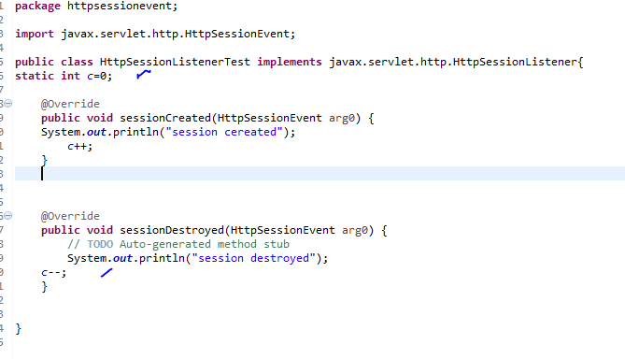

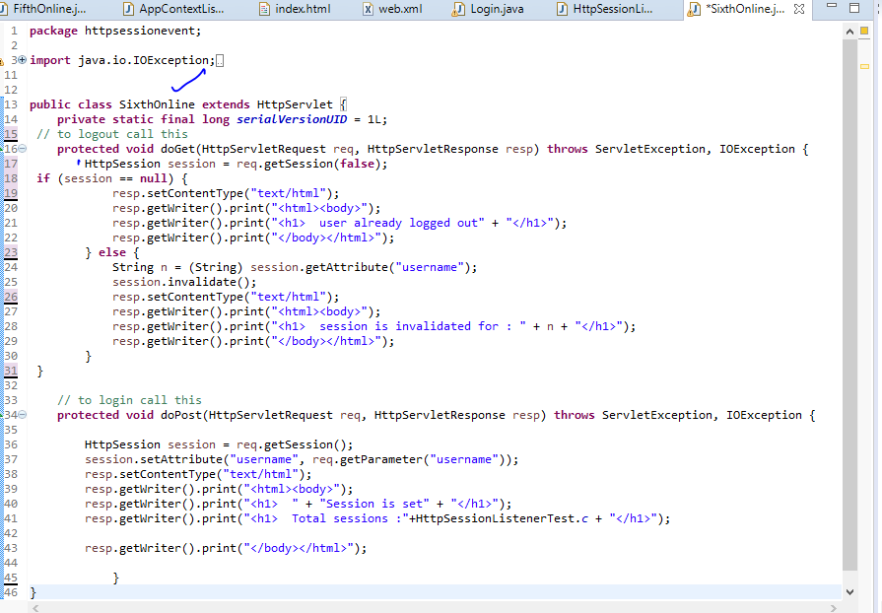

BAKKI KE BHI EVENT LISTENER H -> wo krna h baad me